**Event management system use case Templates**

**Class BSCS 5th self**

**Group members**

**BCSF19E016: Ayesha Asghar**

**BCSF19E022: Tuba Mushtaq**

**BCSF19E024: Amina Zaheer**

**BCSF19E025: Bushra yousaf**

**BCSF19E037: Laraib Anza**

**Submitted to Sir Abid Rafiq**

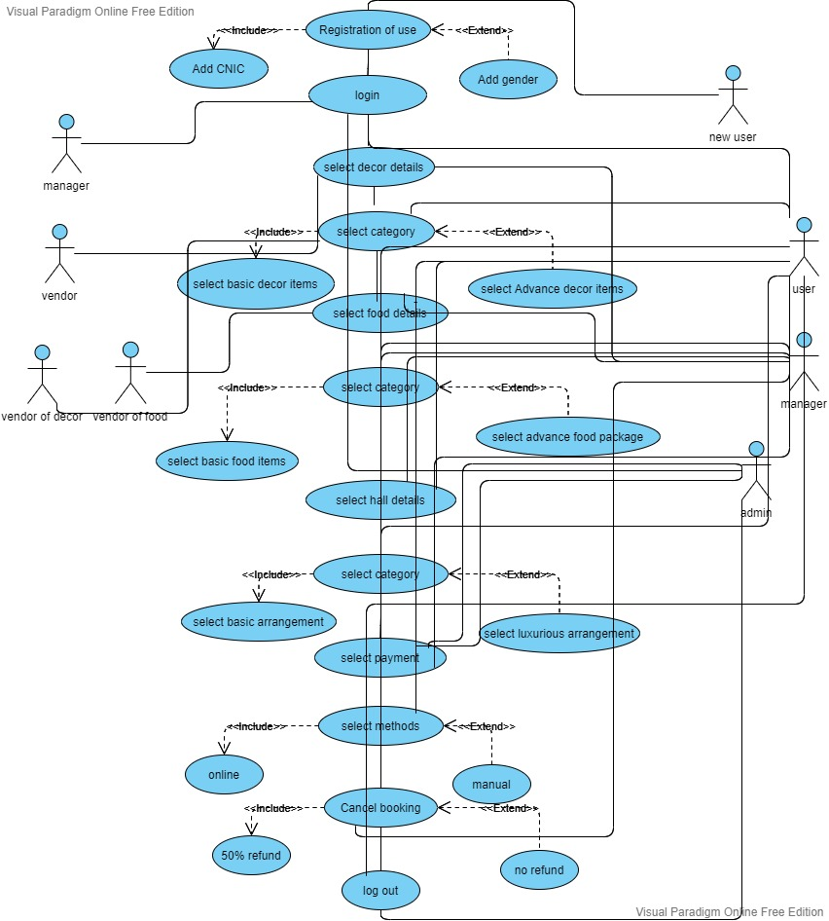

**Name: Amina Zaheer**

**Use case Template 1**

* **Name**- Registration of users
* **Triggers** if users try to access any further details of the event before registration then there appear a message registers yourself before any access.
* **Description**- The users that are interacting with system for the first time they need to registration. They give their CNIC, email, name and contact numbers for registration, after successfully registration they will login to the system any time, only outsiders and new customers need registration admin and managers and staff already register in the system.
* **Actors-** Admin, managers, volunteers, and customers are all the actors of the system.
* **Primary actors-** customers are primary actors
* **Secondary Actors** admin, managers and volunteers are all the secondary actors.
* **Preconditions-** they must have CNIC, email id, contact number then they register to the system.
* **Basic flow-1)** Admin manage the registration process. 2) The users/customers will provide their CNIC, email, name, contact number and password for registration. 3) Admin register the new customers. After successfully registration 4) they will login to the system. 5) After login to the system customers can view their profile and view event and all related details of system. 6) they can book any event and provide all details related their event.
* **Alternative flow-**if users face any query related registration into the system after entering their details they can contact to the manager and manger will handle their queries then ask to users to re-ent**e**r their information**.** Then they easily register to the system.
* **Exception flows-** if users provide any wrong information like CNIC, name and others details they will not able to register. Their registration will be cancel then, there will appear an error on the screen users will be ask to re-enter their correct information.
* **Post condition**- after successfully registration to the system, users profiles create on the system they will easily login to the system by entering their email id, and username after that they can view event details and they can book any event what they want and provide all details related to their event.
* **Status of the system-** necessary details is registration for further process.
* **Stakeholders of the system**-Admin, manager, customers are all the stakeholders of the system because their benefits and lose are associates the system
* **Use case Template 2**
* **Name- Login**
* **Triggers** after entering their details then they click login button and they can easily login to the systems.
* **Description**-for login to the system primary and secondary actors enter their email id, users name and password. Then they are easily login to the system

* **Actors-** Admin, managers, volunteers, and customers are all the actors of the system.
* **Primary actors-** customers are primary actors of the system.
* **Secondary Actors** admin, managers and volunteers are all the secondary actors.
* **Preconditions-** before login to the system users must be registered into the system.
* **Basic flow-1)** customers enter their emails id. 2) The users/customers enter their passwords for login 3) if they enter correct password then they successfully login to the system. 4) then they can book any event and provide all details related their event.
* **Alternative flow-**if users face any query related login into the system after entering their details they can contact to the manager and manger will handle their queries then ask to users to re-ent**e**r their information**.** Then they easily login to the system.
* **Exception flows-** if users enter wrong emails ids and passwords then cant login to the system. And there display an error message on screen. then, users will be ask to re-enter their correct email and password. If users enter wrong their emails and id then the system ask to re-register yourself into the system.
* **Post condition**- after successfully login to the system, users profiles create on the system after that they can view event details and they can book any event what they want and provide all details related to their event.
* **Status of the system-** necessary conditions is login to the system for further process.
* **Stakeholders of the system**-Admin, manager, customers are all the stakeholders of the system because their benefits and lose are associates the system
* **Use case Template 3**
* **Name- Add CNIC**
* **Triggers** if users want to register on the site and if CNIC field is not filled by user then this event will be triggered.
* **Description**- if user want to register on the website then they must give their verified CNIC. After that they can access further details and book any other event .
* **Actors-** Admin, managers, volunteers, and customers are all the actors of the system.
* **Primary actors-** customers are primary actors of the system.
* **Secondary Actors** admin, managers and volunteers are all the secondary actors.
* **Preconditions-** when other required fields are completed then CNIC field will be opened.
* **Basic flow-1)** users enter their emails id. 2) The users/customers enter their passwords for login 3) they then enter their CNIC. 4) then they can book any event and provide all details related their event.
* **Alternative flow-**if users face any query related to entering their CNIC then they can contact to the manager and manger will handle their queries
* **Exception flows-** if users enter in valid CNIC or CNIC that are not verified then there appear an error on the screen and if they enter their CNIC without dashes there also appear an error on the screen .
* **Post condition**- after giving correct CNIC for registration then they are registered to the system and they can easily book an event and others related details.
* **Status of the system-** necessary conditions is giving CNIC for further process.
* **Stakeholders of the system**-Admin, manager, customers are all the stakeholders of the system because their benefits and lose are associates the system
* **Use case Template 4**
* **Name**- cancel booking/event
* **Triggers** if users don’t want to proceed any selected event then by clicking on the cancel booking button. This section will be opened.
* **Description**- if users want cancel the booking then they can cancel the event at any time by clicking on the cancel booking but if they cancel any event within three days then we refund 50% if they cancel any event after three days then we don’t give any refunds. **Actors-** Admin, managers, volunteers, and customers are all the actors of the system.
* **Primary actors-** customers are primary actors
* **Secondary Actors** admin, managers and volunteers are all the secondary actors.
* **Preconditions-**if users don’t want to proceed the event the they cancel the event.
* **Basic flow-1) if** user cancel the event. 2) manager will entertain this query.. 3) manager will report to the admin about cancelation. 4) if the user cancel any event within three days then half payment will be refunded and after three days no refund available.
* **Alternative flow-**if users face any query related booking cancelation they then can contact to the manager and manger will handle their queries
* **Exception flows**- if user cancel any event within specified time and if there is delay in message of event cancelation on the manager side. Then is an error and one third payment will refund.
* **Post condition**- after cancelation of booked event no event will be proceed all related arrangement will be canceled.
* **Status of the system-** an event has been cancelled by the user**.**
* **Stakeholders of the system**-Admin, manager, customers are all the stakeholders of the system because their benefits and lose are associates the system

**Name: Tuba Mushtaq**

**Use case Template-5**

* **Name**- Give and receive payment
* **Triggers**- after clicking the give and receive payment button the further details will be open.
* **Description**- After booking the event and selecting all the details the user will give payment and get verification. Also after placing the order of food and décor the manager will give payment to vendors and get verification. If the event is cancelled within 3 days half payment will be refund.
* **Actors-** Admin, managers, volunteers, vendors and customers are all the actors of the system.
* **Primary Actors-** customers, admin, and managers are primary actors.
* **Secondary Actors-** volunteers and vendors are the secondary actors.
* **Precondition-** The user/customer has to book the event and Manager has to place an order to vendors before giving the payment.
* **Basic flow-**  **1-** After booking the event and selecting all the details the user will give payment through manual or online system and get verification. **2-** Also after placing the order of food and décor the manager will give payment through manual or online system to vendors and get verification. **3-** If the event is cancelled within 3 days half payment will be refund.
* **Alternative flow-** If there is no possibility of online or manual payment, in that case cash will be accepted.
* **Exception flows-** There can be an error occur during entering the payment details then the user will see an error message.
* **Post condition**- When the payment is received, a confirmation message will be send.
* **Status of the system-** at this time payment have been received by the user and given to the vendors.
* **Stakeholders of the System**- Admin, manager, customers, and vendors are all the stakeholders of the system because their benefits and lose are associate with this system.

**Use case Template-6**

* **Name**- Select payment method
* **Triggers**- after clicking the give and receive payment button the user can select the method of payment.
* **Description**- After booking the event and selecting all the details the user will choose the payment method, and also after placing the order of food and décor to vendors the manager will select the payment method.
* **Actors-** Admin, managers, volunteers, vendors and customers are all the actors of the system.
* **Primary Actors-** customers, admin, and managers are primary actors.
* **Secondary Actors-** volunteers and vendors are the secondary actors.
* **Precondition-** The user/customer has to book the event and Manager has to place an order to vendors before choosing the payment method.
* **Basic flow-**  **1-** After booking the event and selecting all the details the user will choose payment method; it can be manual or online. **2-** Also after placing the order of food and décor to vendors the manager will choose the payment method; it can be manual or online.
* **Alternative flow-** If there is no possibility of online or manual payment, in that case cash will be accepted.
* **Exception flows-** There can be an error occur during selecting the payment method then the user will see an error message.
* **Post condition**- When the payment method is selected, a message will be sent that you are paying through this method (manual or online).
* **Status of the system-** at this time payment method have been selected by the user and the manager.
* **Stakeholders of the System**- Admin, manager, customers, and vendors are all the stakeholders of the system because their benefits and lose are associate with this system.

**Use case Template-7**

* **Name**- Give and receive payment through online
* **Triggers**- after clicking the give and receive payment button the user can select the online payment method.
* **Description**- After booking the event and selecting all the details the user will give payment through online method, and also after placing the order of food and décor to vendors the manager will give payment through online method.
* **Actors-** Admin, managers, volunteers, vendors and customers are all the actors of the system.
* **Primary Actors-** customers, admin, and managers are primary actors.
* **Secondary Actors-** volunteers and vendors are the secondary actors.
* **Precondition-** The user/customer has to book the event and Manager has to place an order to vendors before giving the online payment.
* **Basic flow-**  **1-** After booking the event and selecting all the details the user will give payment through online method. **2-** Also after placing the order of food and décor to vendors the manager will c give payment through online method.
* **Alternative flow-** If there is no possibility of online payment, in that case the user can choose manual method.
* **Exception flows-** There can be an error occur during entering the payment details then the user will see an error message.
* **Post condition**- When the payment is done then the person will get a verification message.
* **Status of the system-** at this time payment have been done by the user and the manager.
* **Stakeholders of the System**- Admin, manager, customers, and vendors are all the stakeholders of the system because their benefits and lose are associate with this system.

**Use case Template-8**

* **Name**- Give and receive payment through manual
* **Triggers**- after clicking the give and receive payment button the user can select the manual payment method.
* **Description**- After booking the event and selecting all the details the user will give payment through manual method, and also after placing the order of food and décor to vendors the manager will give payment through manual method.
* **Actors-** Admin, managers, volunteers, vendors and customers are all the actors of the system.
* **Primary Actors-** customers, admin, and managers are primary actors.
* **Secondary Actors-** volunteers and vendors are the secondary actors.
* **Precondition-** The user/customer has to book the event and Manager has to place an order to vendors before giving the manual payment.
* **Basic flow-**  **1-** After booking the event and selecting all the details the user will give payment through manual method. **2-** Also after placing the order of food and décor to vendors the manager will give payment through manual method.
* **Alternative flow-** If there is no possibility of manual payment, in that case the user can choose online method.
* **Exception flows-** There can be an error occur during manual payment then the user will pay online or in cash.
* **Post condition**- When the payment is done then the person will get a verification message.
* **Status of the system-** at this time payment have been done by the user and the manager.
* **Stakeholders of the System**- Admin, manager, customers, and vendors are all the stakeholders of the system because their benefits and lose are associate with this system.

**Name: Laraib Anza**

**Use case Template 9**

* **Name**-Select Hall Details
* **Triggers**- ending up by booking the menu the hall details section will be opened.
* **Description**- the user/customer will specify the hall details, and manager will work accordingly.
* **Actors-** Admin, managers, volunteers, and customers are all the actors of the system.
* **Primary -** customers are primary actors and admin, managers and volunteers are all the secondary actors.
* **Secondary actors**- admin, managers and volunteers are all the secondary actors.
* **Preconditions-** Before selecting the hall details user/customer should select food details.
* **Basic flow-**Admin and manager manage the process of gathering hall details. The users/customers will tell their requirement about hall like number of people, if they want basic package or luxurious package.
* **Alternative flow-**if users face any query related to the selection of hall details then users will contact to the manager at the given contact number then manger will handle their queries
* **Exception flows- if** something is damaged related to catering, decoration etc., or if user/customer make some mistake while specifying the hall details.
* **Post condition**- now the user will have to choose to have the basic or luxurious arrangements
* **Status of the system-** at this time the user have visited the select hall details section.
* **Stakeholders of the system**-Admin, manager, customers are all the stakeholders of the system because their benefits and lose are associates the system.

**Template-10**

* **Name**- Select Basic Arrangements
* **Triggers**- by clicking on the button of basic hall arrangements then the rest of the details will be appeared over there.
* **Description**- the user will either choose the basic hall arrangements then detail list will be previewed.
* **Actors-** Admin, managers, volunteers, and customers are all the actors of the system.
* **Primary actors-** users/customers will be the primary actors
* **Secondary actors-** admin, managers and volunteers are all the secondary actors.
* **Preconditions-** Before reaching this section the user/customer will have to visit the panel of select hall details.
* **Basic flow- (1)** -when the user/customer will choose the basic hall arrangement from the given list then user will specify the number of people and the rest of things that are required.

**(2)-**Now the manager will make the arrangements accordingly

* **Alternative flow-**if users face any query related to the selection of basic hall arrangements then users will contact to the manager and manger will handle their queries
* **Exception flows-** if user leaves any required field empty while specifying the basic hall arrangements then the error message will be displayed.
* **Post condition**- now the event is in the ready state.
* **Status of the system-** the user is selecting the hall details
* **Stakeholders of the system**-Admin, manager, customers are all the stakeholders of the system because their benefits and lose are associates the system

**Template-11**

* **Name**- Select Luxurious Arrangement
* **Triggers**- by clicking on the button of luxurious hall arrangements the rest of the details will be appeared over there.
* **Description**- When the user will choose the luxurious hall arrangements then detail list will be previewed.
* **Actors-** Admin, managers, volunteers, and customers are all the actors of the system.
* **Primary actors-** users/customers will be the primary actors
* **Secondary actors-** admin, managers and volunteers are all the secondary actors.
* **Preconditions-** Before selecting the hall details user/customer should select food details.
* **Basic flow- (1)** -when the user/customer will choose the luxurious hall arrangement from the given list then user will specify the number of people and the rest of things that are required.

**(2)-**Now the manager will make the arrangements accordingly

* **Alternative flow-**if users face any query related to the selection of hall details then users will contact to the manager and manger will handle their queries
* **Exception flows-** if user leaves any required field empty while specifying the basic hall arrangements then the error message will be displayed.
* **Post condition**- now the event is in the ready state.
* **Status of the system-** the user is selecting the hall details.
* **Stakeholders of the system**-Admin, manager, customers are all the stakeholders of the system because their benefits and lose are associates the system

**Template-12**

* **Name**- Log-out
* **Triggers**- by clicking on the button of logout then users will log out from the system.
* **Description**-At first the user/customer will register at the site then the user will log in on the site to select décor details, food details, hall details and then after selecting the payment details user will log out from the system and then if user wants to check the progress of event details he/she can log in to site anytime.
* **Actors-** Admin, managers, volunteers, and customers are all the actors of the system.
* **Primary actors-** users/customers will be the primary actors
* **Secondary actors-** admin, managers and volunteers are all the secondary actors.
* **Preconditions-** beforelogging out of the site user should register at the site then log in to select and specify the décor details, food details, hall details and the payment method**.**
* **Basic flow- (1)** -when the user/customer will click on the log out button then if there are no mistakes done by user and all if all the required fields are successfully filled then the user will log out from the system smoothly.
* **(2)-**Now the manager will make the arrangements according to the specifications of the user.
* **Exception flows-** if user leaves any required field empty while specifying the décor details, food details, hall details and the payment methodthen user can’t log out from the system before filling the missing details.
* **Status of the system-** the user is logging out of the site
* **Stakeholders of the system**-Admin, manager, customers are all the stakeholders of the system because their benefits and lose are associates the system

**Name : Bushra yousaf**

**Template-13**

* **Name**- **Select Food Details**
* **Triggers**- by clicking on the button of Select Food Details further details will be displayed over there.
* **Description**- the user/customer will specify the food details that which type of menu they want in the event, number of people in the event. Now the manager will work accordingly like he will order the catering services from vendors. Suppliers will deliver the ordered food items.
* **Actors-** Admin, managers, volunteers, suppliers, vendors, and customers are all the actors of the system.
* **Primary actors-** users/customers and manager will be the primary actors.
* **Secondary actors-** admin, managers, suppliers, vendors and volunteers are all the secondary actors.
* **Preconditions-** beforeselecting the food details the user should specify the decoration details.
* **Basic flow- (1)** -when the user/customer will click on the Select Food Details button then the further detail list will be opened there **(2)-**Now the manager will make the arrangements according to the specifications of the user.
* **Exception flows-** if user selects any food item that is not available , and if any ordered food item is spoiled.
* **Status of the system-**  food details are being selected.
* **Stakeholders of the system**-Admin, manager, customers are all the stakeholders of the system because their benefits and lose are associates the system

**Template-14**

* **Name**- **Select category**
* **Triggers**- by clicking on the button of Select Category further details will be displayed over there.
* **Description**- the user/customer after specifying the food details that which type of menu they want in the event, number of people in the event and now they after clicking on the select category option they will have to choose from basic and advanced menus. So from now on manager will work accordingly like he will order the catering services from vendors. Suppliers will deliver the ordered food items.
* **Actors-** Admin, managers, volunteers, suppliers, vendors, and customers are all the actors of the system.
* **Primary actors-** users/customers and manager will be the primary actors.
* **Secondary actors-** admin, managers, suppliers, vendors and volunteers are all the secondary actors.
* **Preconditions-** beforeselecting the food details category the user should have visited the Select Food Details section.
* **Basic flow- (1)** -when the user/customer will click on the Category button then the further detail list will be opened there from where user will have to choose one of the two given categories **(2)-**Now the manager will make the arrangements according to the specifications of the user.
* **Exception flows-** if user selects any food item that is not available , and if any ordered food item is spoiled.
* **Status of the system-**  food details are being selected.
* **Stakeholders of the system**-Admin, manager, customers are all the stakeholders of the system because their benefits and lose are associates the system

**Template-15**

* **Name**- **Select Basic Menu**
* **Triggers**- by clicking on the button of **Select Basic Menu** further details will be displayed over there.
* **Description**- the user/customer will specify that which type of basic menu they want in the event, number of people in the event .So from now on manager will work accordingly like he will order the catering services from vendors. Suppliers will deliver the ordered food items.
* **Actors-** Admin, managers, volunteers, suppliers, vendors, and customers are all the actors of the system.
* **Primary actors-** users/customers and manager will be the primary actors.
* **Secondary actors-** admin, managers, suppliers, vendors and volunteers are all the secondary actors.
* **Preconditions-** beforevisiting the **Select Basic Menu** category the user should have visited the Select Food Details and Select Category section.
* **Basic flow- (1)** -when the user/customer will click on the **Select Basic Menu** button then the further detail list will be opened there from where user will have to fill the basic menu details according to their specifications

**(2)-**Now the manager will make the arrangements according to the specifications of the user.

* **Exception flows-** if user selects any food item that is not available , and if any ordered food item is spoiled.
* **Status of the system-**  food details have been selected.
* **Stakeholders of the system**-Admin, manager, customers are all the stakeholders of the system because their benefits and lose are associates the system

**Template-16**

* **Name**- **Select Advanced Menu**
* **Triggers**- by clicking on the button of **Select Advanced Menu** further details will be displayed over there.
* **Description**- the user/customer will specify that which type of advanced menu they want in the event, number of people in the event .So from now on manager will work accordingly like he will order the catering services from vendors. Suppliers will deliver the ordered food items.
* **Actors-** Admin, managers, volunteers, suppliers, vendors, and customers are all the actors of the system.
* **Primary actors-** users/customers and manager will be the primary actors.
* **Secondary actors-** admin, managers, suppliers, vendors and volunteers are all the secondary actors.
* **Preconditions-** beforevisiting the **Select Advanced Menu** category the user should have visited the Select Food Details and Select Category section.
* **Basic flow- (1)** -when the user/customer will click on the **Select Advanced Menu** button then the further detail list will be opened there from where user will have to fill the advanced menu details according to their specifications

**(2)-**Now the manager will make the arrangements according to the specifications of the user.

* **Exception flows-** if user selects any food item that is not available , and if any ordered food item is spoiled.
* **Status of the system-**  food details are being selected.
* **Stakeholders of the system**-Admin, manager, customers are all the stakeholders of the system because their benefits and lose are associates the system

**Ayesha Asghar**

**Use case Template 17**

* **Name**-Select Decor
* **Triggers**- the list of décor item will be displayed
* **Description**- the user/customer will specify the décor item and manager will work book order accordingly.
* **Actors-** Admin, managers, volunteers, and customers are all the actors of the system.
* **Primary -** customers are primary actors
* **Secondary actors**- admin, managers and volunteers are all the secondary actors.
* **Preconditions-t**he user should register and login on the site to specify the décor details.
* **Basic flow-**1:The customer/user will tell their requirement about the decoration.
* **2:**adminand manager will manage the process of decoration details.
* **Alternative flow-**if users face any query related to the selection of decor details then users will contact to the manager at the given contact number then manger will handle their queries
* **Exception flows- if** user will try to write select any detail that is not available in the list, then error message will be displayed on screen.
* **Post condition**- the user will have to choose from the given two categories.
* **Status of the system-** the décor detail are being selected.
* **Stakeholders of the system**-Admin, manager, customers are all the stakeholders of the system because their benefits and lose are associates the system.

**Use case Template 18**

* **Name**-select category with expenses
* **Triggers**- by clicking on the select category with expenses and further detail will be opened.
* **Description**- the user will visit select category with expenses sections and then customer will choose from the given category
* **Actors-** Admin, managers, volunteers, and customers are all the actors of the system.
* **Primary -** customers are primary actors
* **Secondary actors**- admin, managers and volunteers are all the secondary actors.
* **Preconditions-**before visiting the select category and expenses sections the user should visit the select décor details sections.
* **Basic flow-**1: when the customer will click on the select category with expenses button now customer will to choose from the basic decor item and advanced décor item.
* **2:**admin and manager will manage the process of select category with expenses.
* **Alternative flow-**if users face any query related to the selection of decor details then users will contact to the manager at the given contact number then manger will handle their queries
* **Exception flows- if** user will try to write select any detail that is not available in the list, then error message will be displayed on screen.
* **Post condition**- the user will be able to specify the food details.
* **Status of the system-** the décor detail are being selected.
* **Stakeholders of the system**-Admin, manager, customers are all the stakeholders of the system because their benefits and lose are associates the system.

**Use case Template 19**

* **Name**- select basic décor item
* **Triggers**- by clicking on the basic decor item button. The further detailed will be opened
* **Description**- the user will choose the basic category of décor and then select different decor item that are displayed in basic décor list.
* **Actors-** Admin, managers, volunteers, and customers are all the actors of the system.
* **Primary -** customers are primary actors
* **Secondary actors**- admin, managers and volunteers are all the secondary actors.
* **Preconditions**-before visiting the basic decor items the users should visit select category with expenses
* **Basic flow-**1:user visit the basic decor detail list and visit all the decor item with expenses.

**2**:select any item of decors that they want under the range of basics category.

**3:**manager will take order of basic décor detailed and arrange accordingly.

* **Alternative flow-**if users face any query related to the selection of decor details then users will contact to the manager at the given contact number then manger will handle their queries
* **Exception flows- if** user will try to write select any detail that is not available in the list, then error message will be displayed on screen.
* **Post condition**- after selecting the basic category of decor the event will be organized. According to this, food details will be selected.
* **Status of the system-** the basic décor details has been selected.
* **Stakeholders of the system**-Admin, manager, customers are all the stakeholders of the system because their benefits and lose are associates the system.

**Use case Template 20**

* **Name**- select Advanced décor item
* **Triggers**- by clicking on the advanced decor item button. The further detailed will be opened
* **Description**- the user will choose the advanced category of décor and then select different decor item that are displayed in advanced décor list.
* **Actors-** Admin, managers, volunteers, and customers are all the actors of the system.
* **Primary -** customers are primary actors
* **Secondary actors**- admin, managers and volunteers are all the secondary actors.
* **Preconditions**-before visiting the advanced decor items the users should visit the basic décor iitem.
* **Basic flow-**1:user visit the advanced decor detail list and visit all the decor item with expenses.

**2**:select any item of decors that they want under the range of advanced category.

**3:**manager will take order of advanced décor detailed and arrange accordingly.

* **Alternative flow-**if users face any query related to the selection of decor details then users will contact to the manager at the given contact number then manger will handle their queries
* **Exception flows- if** user will try to write select any detail that is not available in the list, then error message will be displayed on screen.
* **Post condition**- after selecting the advanced category of décor item. User should select food details for event.
* **Stakeholders of the system**-Admin, manager, customers are all the stakeholders of the system because their benefits and lose are associates the system.

**Sequence diagrams**

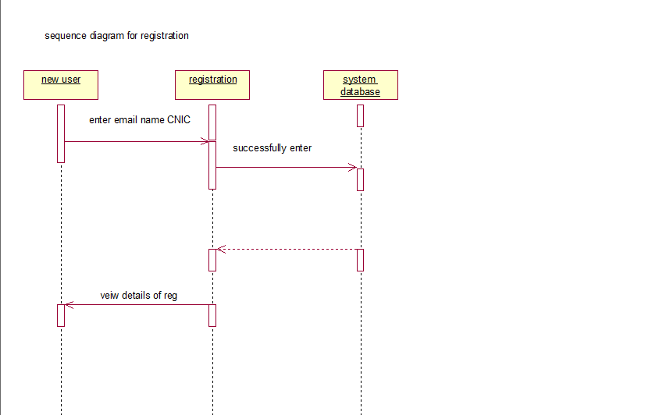

**2**

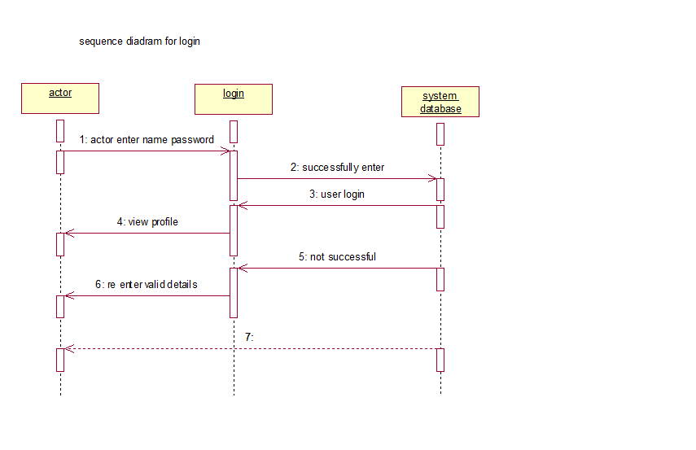

**3**

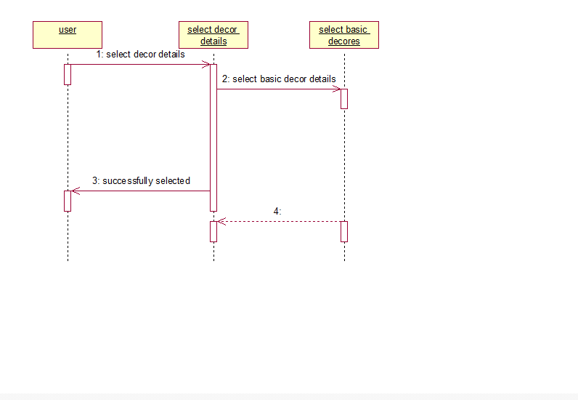

**4**

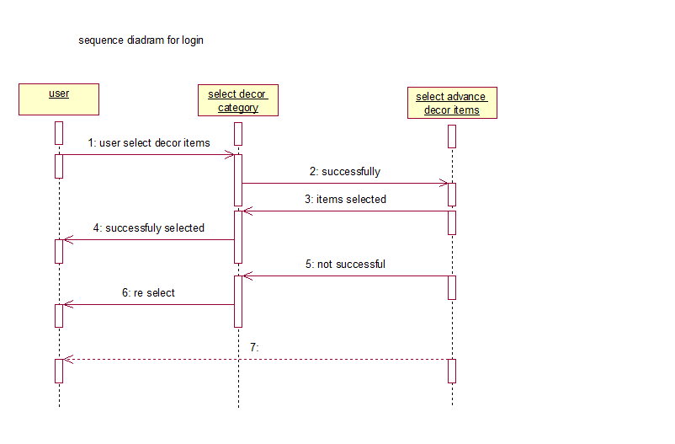

**5**

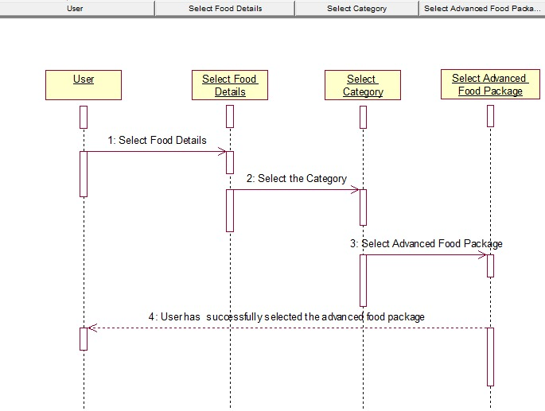

**6**

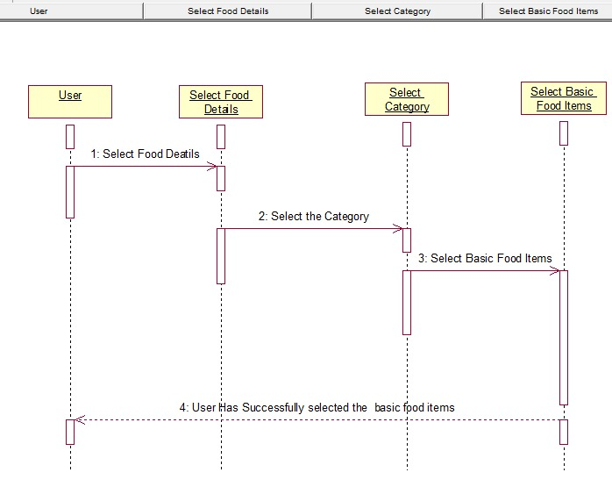

**7**

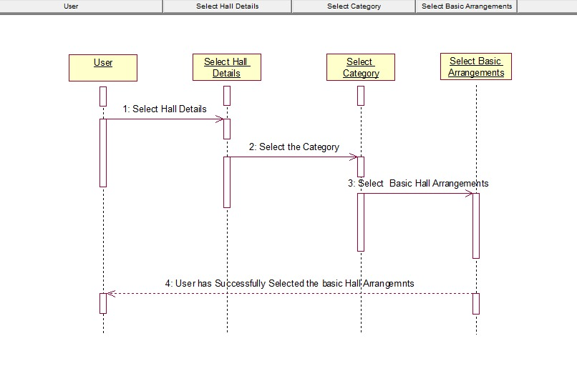

**8**

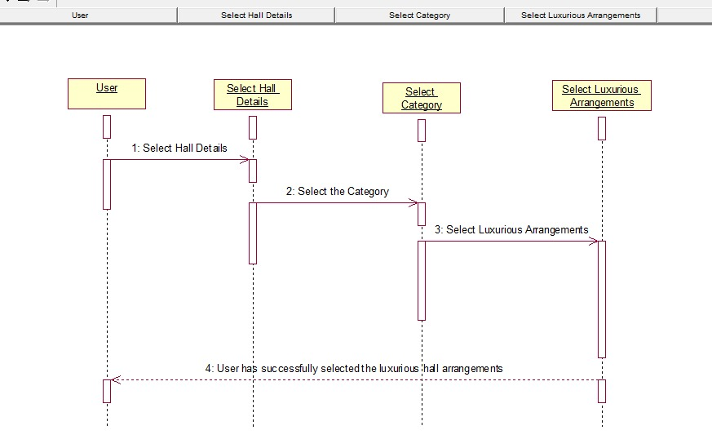

**9**

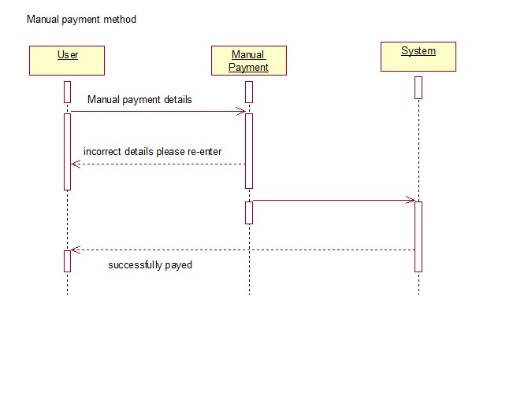

**10**

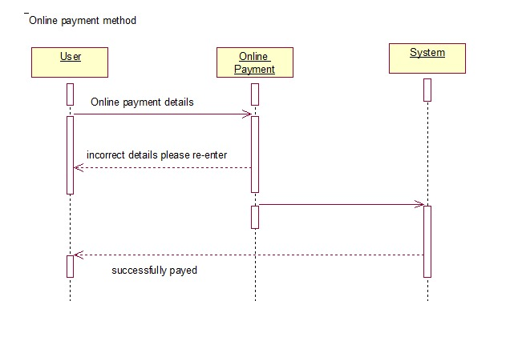

**Collaborations diagrams**

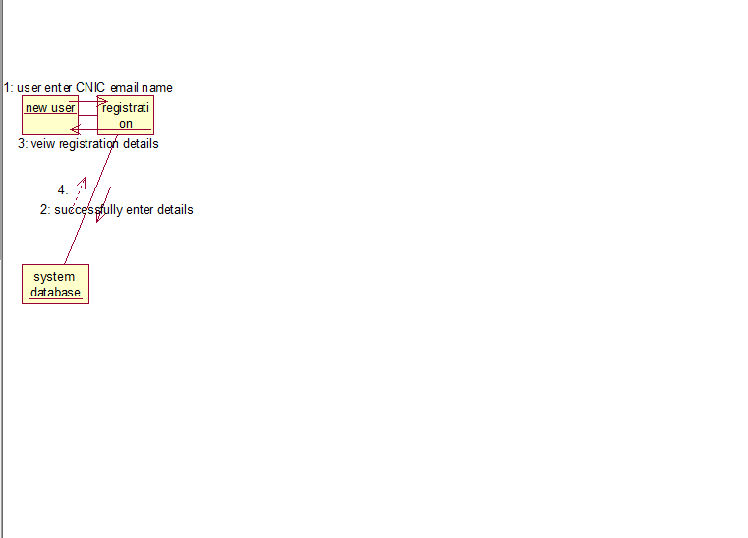

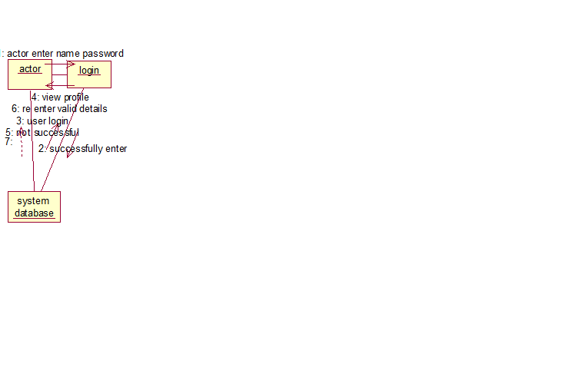

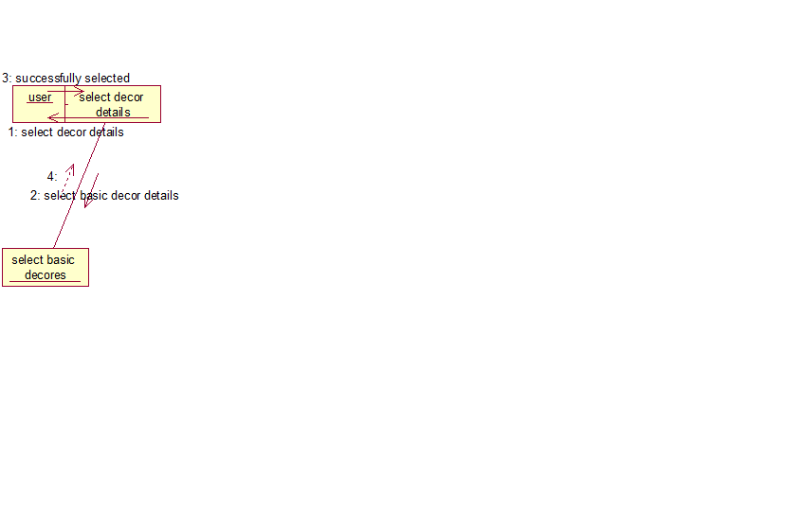

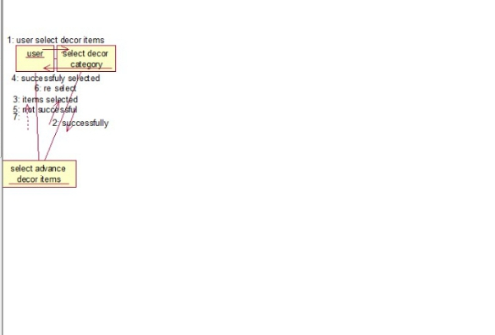

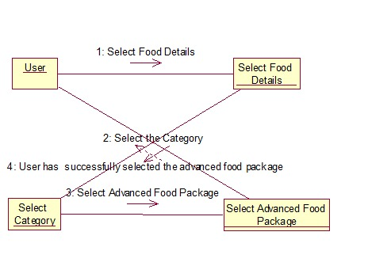

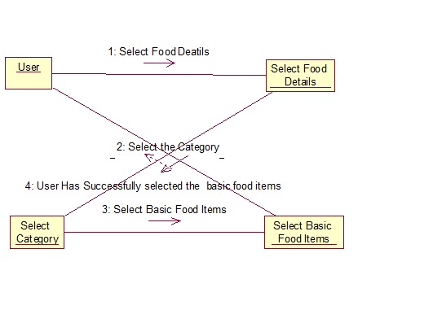

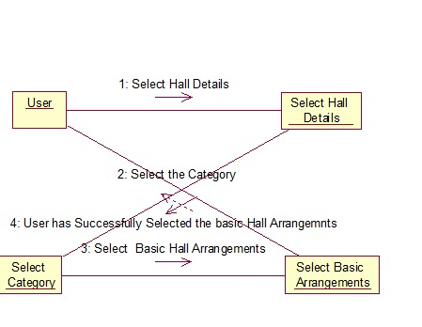

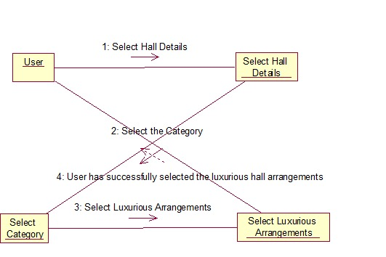

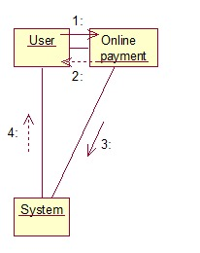

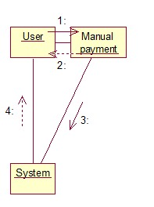

**Activity diagrams**

**1**

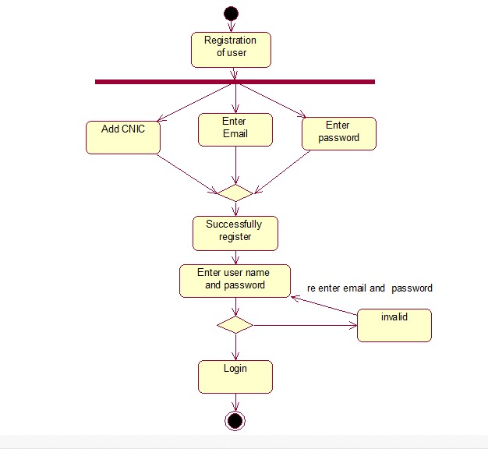

**2**

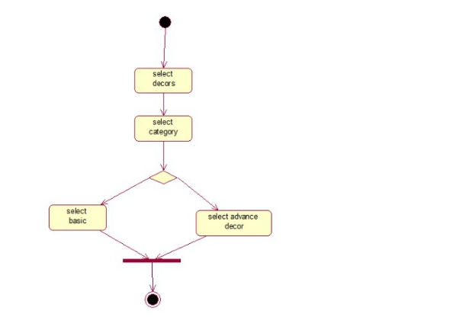

**3**

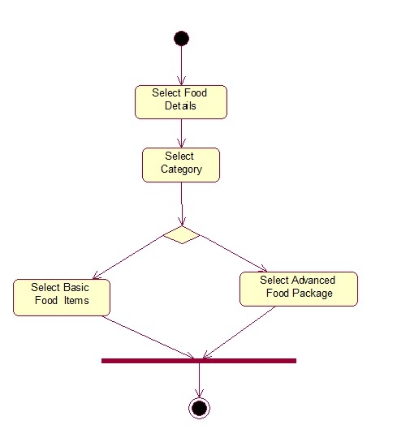

**4**

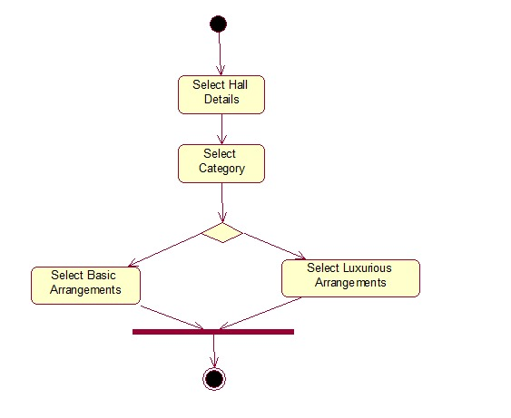

**5**

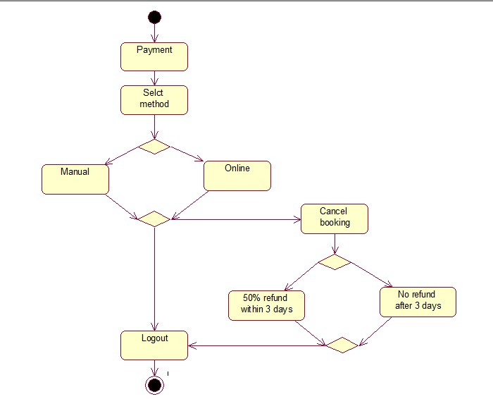

**Glossary**

**Glossary of EMS**

**Use case Diagram:** A use case diagram is a graphical depiction of a user's possible interactions with a system. A use case diagram shows various use cases and different typesof users the system contains**.**

**Actor:** The users that interact with a system. An actor can be a person, an organization, or an outside system that interacts with your application or system.

For example in our system new user, user, manager, vendors, admin are the actors.

**Manager:** Manager is an actor in the system who will manage the event.

**Vendor**:  Vendor is another actor in the system from them different things will be ordered.

**New User** :  New user is an actor in the system who will first register and then will log in the system and book the event.

**User** : User is an actor which will user our online event management system like manager , admin , new user etc.

**Admin** : Admin is an actor in the system who will manage the event management system.

**Template**:   A pattern that is used as a guide to the form of a piece being made.

For example in ems different templates for different use cases are made.

**Trigger** : A trigger is the initiator of a use case. It is what causes the use case to start.

**Primary Actor** : Primary actors initiate a use case and hence are somewhat independent. For example in this ems user , admin and manager are primary actors

**Secondary Actor** : Secondary actors, on the other hand, are used by the system but they do not interact with the system on their own. In this ems , vendors and volunteers are secondary actors.

**Description**: description is a statement that gives details about someone or something.

**Pre Condition**  : Pre-conditions are the things that must be true before a method is called.

**Post Condition** : Post-conditions are the things that must be true after the method is complete.

**Alternative flow** : An alternate flow describes a scenario other than the basic flow that results in a user completing his or her goal.

**Exception flow** : An exception flow is an unintended path through the system usually as a result of missing information or system availability issues.

**Status of System** :  It tells that after performing the current operation what is the state of the system .

Stakeholder of the system : A stakeholder in the architecture of a system is an individual, team, organization, or classes thereof, having an interest in the realization of the system. Admin, manager, customers, and vendors are all the stakeholders of the system because their benefits and lose are associate with this system.

**Sequence diagram** : A sequence diagram or system sequence diagram shows object interactions arranged in time sequence

**Activity diagram** :  Activity diagram is a  graphical representations of workflows of stepwise activities and actions

**Collaboration diagram** :  Collaboration Diagram represents the interaction of the objects to perform the behavior of a particular use case or a part of use case.

**Domain model** : The domain model is a representation of meaningful real-world concepts relevant to the domain that need to be modeled in software. The concepts include the data involved in the business and rules the business uses in relation to that data.

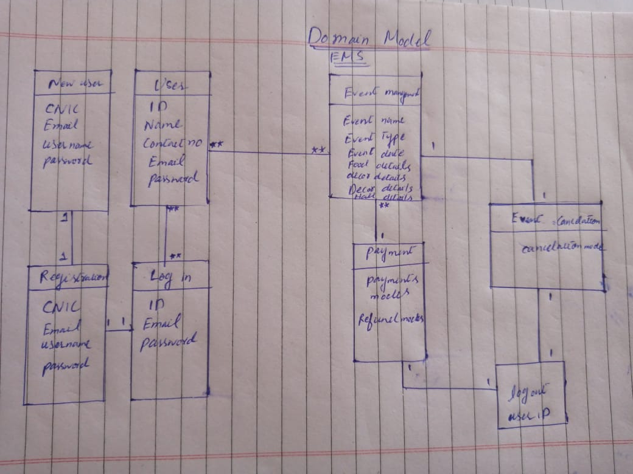**Domain Model**